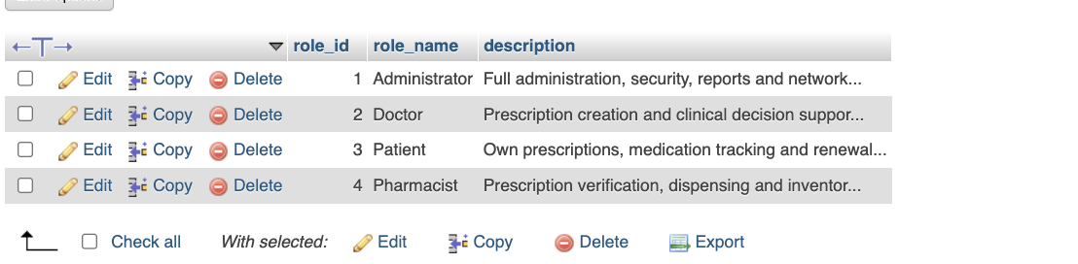
Defines the role catalogue used by the access-control model. Each role_id is paired with a role_name and description. The visible roles are Administrator, Doctor, Patient, and Pharmacist, with descriptions summarizing their responsibilities such as administration, prescribing, personal medication access, and prescription verification or dispensing. Keeping roles in a reference table allows account-to-role assignments to be handled consistently through the separate user_roles mapping table.

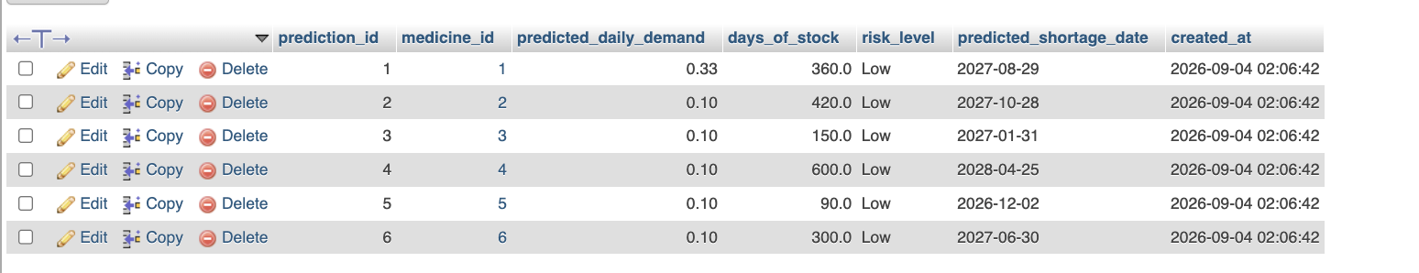
Stores medicine shortage forecasting results. Each prediction_id links to a medicine_id and records predicted_daily_demand, days_of_stock, risk_level, predicted_shortage_date, and created_at. The visible predictions are currently Low risk and estimate different remaining stock durations, from 90 days to 600 days. This table therefore captures the output of shortage calculations in a form that can be reviewed later and compared with current inventory or external shortage information.

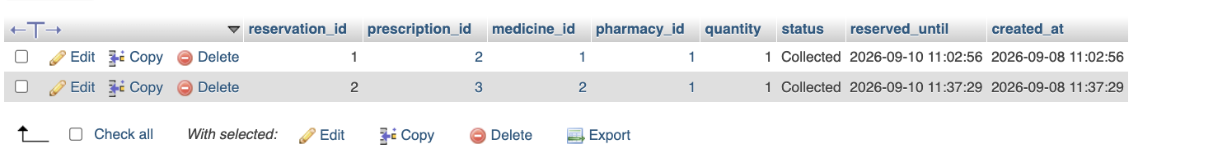
Handles temporary pharmacy stock reservations for prescriptions. Each reservation_id links a prescription_id, medicine_id, and pharmacy_id and stores the reserved quantity, reservation status, reserved_until deadline, and created_at timestamp. The visible reservations are marked Collected for two prescriptions at pharmacy 1. This allows stock to be committed to a particular prescription before final dispensing and provides a clear time and status record for the reservation lifecycle.

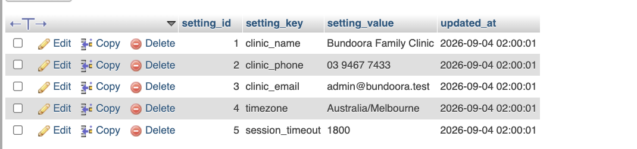
Stores application-wide configuration as key/value settings. Each row contains setting_id, setting_key, setting_value, and updated_at. The visible settings define the clinic name, phone number, email address, timezone, and session_timeout value. This design keeps operational configuration outside application code, making common values such as Australia/Melbourne timezone and the session timeout centrally available and independently updateable.

Records medicine shortage information associated with Australia's Therapeutic Goods Administration. Each tga_shortage_id links to a medicine_id and stores medicine_text, tga_reference, status, expected_resolution, source_url, and updated_at. The visible record identifies Amoxicillin 500mg as having Limited availability with reference DEMO-TGA-001 and an expected resolution date. This provides a structured place to connect external shortage notices with the internal medicine catalogue.

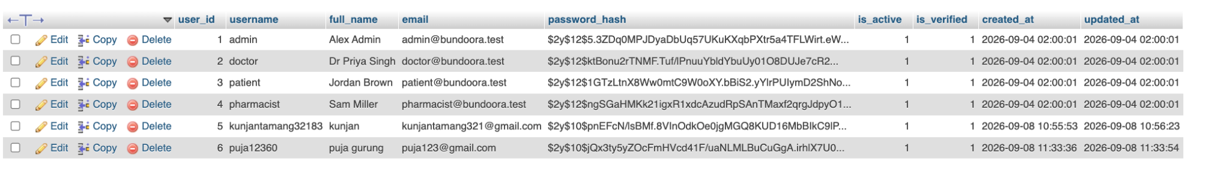
Serves as the central account and authentication table. Each user_id stores username, full_name, email, password_hash, is_active, is_verified, created_at, and updated_at. The supplied records include administrative, doctor, patient, pharmacist, and additional patient accounts. Passwords are represented by hashes rather than readable passwords, while the active and verified flags separate account availability and verification state. Role assignments are kept independently in user_roles rather than embedded directly in this table.

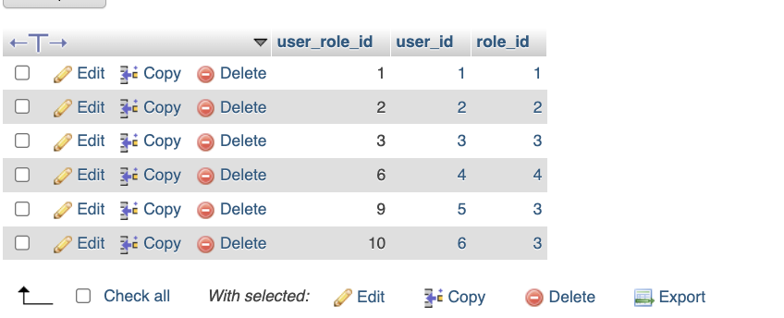
Maps user accounts to the role catalogue. Each user_role_id connects a user_id with a role_id, allowing authentication information in users to remain separate from authorization information in roles. The visible mappings assign the administrator, doctor, patient, and pharmacist accounts to their corresponding roles, with the two additional users also mapped to the Patient role. This junction-table design can support role-based access checks without duplicating role descriptions across individual user records.

